Contents
What is supplier EDI and what does it provide 2
Overall operation of MACI supplier EDI 3
What functions at MACI are affected by Supplier EDI 6
Transaction Set Envelopes 8
Transactions supported and required by MACI Supplier EDI 11
830 – Forecast Planning Schedule 12
856 – Advanced Shipping Notice (ASN) 15
824 – Application Advice 20
997 – Functional Acknowledgement 22
Labels – Why and how MACI uses them 24
Label specifications 26
VAN – Value added networks 29
Common issues found in MACI Supplier EDI 31

What is supplier EDI and what it provides

“EDI” (Electronic Data Exchange).

Supplier EDI is MACI’s method of automatically communicating with suppliers what and when MACI needs parts and raw material shipped.

It is also MACI’s method of receiving information from suppliers about when they can meet requirements MACI has set for the supplier.

It automates the process so it can be current and reliable. This reduces the manual manipulation of information about shipments which is time consuming and expensive.

Suppliers providing production parts and raw materials are required to use EDI for orders and shipments.

Overall operation of MACI supplier EDI

MACI orders parts from supplier
MACI 830 Supplier
Supplier acknowledges order
997

Overall operation of MACI supplier EDI

Supplier builds parts, ships and sends ASN
856
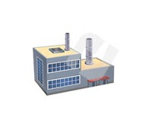

MACI Receives and processes ASN

Overall operation of MACI supplier EDI

If there is problem with an ASN MACI sends Application Advice and supplier must reprocess and send a replacement ASN
824

MACI Receives truck and Places parts in inventory

What functions at MACI are affected by Supplier EDI

Purchasing – Uses EDI to order direct receipts from suppliers of parts needed to maintain production.

Receiving – Uses EDI to identify information related to each container on a shipment received.

Inventory- Quantities in inventory are updated by data included in the ASN from EDI.

Production – EDI provides information about quantities received, when expected and lot numbers for each container (pallet).

Production Control – Uses EDI in the plant scheduling process.
What functions at MACI are affected by Supplier EDI

Quality Assurance – The lot numbers and label serial numbers from EDI (ASN) are used by QA to track down production and quality issues.

Transaction Set Envelopes

EDI is organized into “Transaction Sets”. Transaction sets group EDI messages into orders (830), shipments (856), error responses (824) and acknowledgements (997).

Transaction set Envelopes wrap a message sent into beginning segments that identify the sender and receiver of the message and the end of the message.

The beginning segments provide information that can be recognized by the VAN which is used to direct the message to the right user and location.
Transaction Set Envelopes

MACI uses a protocol called X-12 that is sponsored by ANSI (American National Standards Institute).

X12 envelopes start with an “ISA” and end with an “IEA” segment.

Segments “GS/GE” and “ST/SE” are also included in the enveloping.

GS and GE segments identify functional groups. Only one transaction set type can exist within a functional group, i.e., only 856s can be grouped together or only 824s can be grouped together.
Transaction Set Envelopes

ST and SE segments break out transaction sets.

ISA*00* *00* *ZZ*MC000111 *12*2221234756 *150710*1254*U*00400*000075828*0*P*^~
GS*PS*222221144*X422CONN*20150710*1254*75828*X*004010~
ST*830*5828~
|
There must be at least one GS/GE segment match in each message
ISA/IEA marks a complete message
The ST starts a new transaction set
|
|
|
SE*296*5828~
GE*1*75828~
IEA*1*000075828~

Transactions supported and required by MACI Supplier EDI

830 – Issues MACIs forecast plans to ship. It also indicates firm ship requirements.

856 - Issues an Advanced Shipment Notice (ASN) to MACI from the supplier. It must arrive before the shipment itself.

824 – Application advice. This transaction set informs the supplier that a problem has occurred with an 856 (ASN). The 824 sent by MACI to the supplier.

997 – Acknowledgement. This transaction set informs the sender of a transaction set that it was received.

830 – Forecast Planning Schedule

Used by MACI to issue requirements and expected demand to suppliers.

Expected demand is referred to as “planned releases”. As production is scheduled and demand estimated Production Planning or Purchasing (for raw materials) issue orders for parts to meet the needs of production.

Requirements are referred to as “firm releases”. These are orders for parts to build product for short term. Usually this is the next week.

Both “planned releases” and “firm releases” are contained in the current 830.
830 – Forecast Planning Schedule

830s are issued weekly (usually Friday) for most domestic suppliers.

When an 830 is issued for a part it is meant to replace the order for all the weeks in the 830 for that part.

It is the supplier’s responsibility to update and maintain its database with information supplied in a sent 830.

830 – Forecast Planning Schedule
ISA*00* *00* *ZZ*MC999111 *ZZ*ED99945 *150710*0813*U*00400*000075792*0*P*^
GS*PS*903450223*ED99945*20150710*0813*75792*X*004010~
ST*830 Indicates this is an 830 transaction

ST*830*5792~
BFR*05*115027**DL*A*20150101**20150710~
N1*16*MACI*98*MAC~
PER*BD*MACI USER NOT SPECIFIED~
N1*SU*EDS WIDGETS INC*92*E999~
N3*#774005*450 Washtenaw Ave~
N4*ANN ARBOR*MI*48999-2000*USA~
PER*SU*HANNAH~
LIN**BP*5000999***PD*PARTDESC*PO*P224890~
*C*C* indicates this date is a firm release
UIT*EA~
N1*ST*Michigan Automotive Compr*92*999~
N3*2400 N. Dearing Road~
N4*Parma*MI*49269*USA~
FST*40000*C*C*20150710****RE*010~
FST*20000*D*W*20150727~
FST*20000*D*W*20150803~
*D*W* indicates this date is a planned release
FST*20000*D*W*20150810~
FST*20000*D*W*20150817~

856 – Advanced Shipping Notice (ASN)

An 856 (ASN) must be sent for each shipment. It must arrive at MACI before the shipment does.

When the ASN arrives at MACI it is checked for valid information and either accepted and updated to the database or rejected. If rejected an 824 is sent back to the supplier.

The information contained in the ASN is used by MACI for receiving, inventory and production. The 856 should accurately reflect information about the shipment. This includes all information on the container/master labels.

The ASN is matched to the label during receiving using the container serial number. The serial number consist of the supplier ID (up to six characters long) and a 9 character sequence number which cannot be reused for 3 years.
856 – Advanced Shipping Notice (ASN)

There are two types of labels: container (child) and master. There are serial numbers for each.

The master label indicates quantities and serial numbers for each container under it.

Some master serial numbers match the container serial number. This can only happen if there is just one container assigned to a master. It must be agreed to by the MACI department and planner issuing the 830 for that item.

856 – Advanced Shipping Notice (ASN)

In most cases there are multiple containers for each master label. In this case each serial number (including master) must be unique for three years.

PO and PO-release must be open.

Supplier lot number is used by MACI to track parts used in production by MACI. We have contractual agreements with our largest customers and our suppliers are required to keep records of production also. The container and lot numbers will be used to refer specific production runs.

856 – Advanced Shipping Notice (ASN)
ISA*00* *00* *ZZ*ED99945 *ZZ*MC999111 *150710*1157*U*00401*000001212*0*P*
GS*SH*ED99945*906850222*20150710*1157*1212*X*004010~
ST*856*12120001~
ST*856 indicates this is an ASN
BSN*00*00060239*20150710*11574000~
DTM*011*20150710*07080000~
HL*1**S~
TD1******N*68537~
TD5**2*ALL~
TD3*TL**1~
REF*BM*00060239~
N1*16**98*MAC~
Purchase order number and PO release number
N1*ST**92*999~
MACI Part number
Master serial number
N1*SU**92*E999~
HL*2*1*T~
LIN**PG*XX~
REF*LS*E999003477878~
HL*3*2*I~
LIN**BP*5000999**00***PO*P224890*RL*0010*SL*9102309453*************PG*XX~
SN1**3300*LB~
Supplier’s lot number
REF*LS*E999003477878~
Container Serial number
HL*4*1*T~
856 – Advanced Shipping Notice (ASN)
ISA*00* *00* *12*E888A654 *ZZ*45500044 *150713*1529*U*00401*000068254*0*P*>~
GS*SH*606041919*9034500223*20150713*1529*68254*X*004010~
ST*856*000600001~
BSN*00*135113*20150713*1516~
Purchase order number and PO release number
DTM*011*20150713*1516~
MACI Part number
Master serial number
|
|
LIN**PG*XX~
REF*LS*E888A1500071351~
HL*3*2*I~
LIN**BP*MC447126-0880*****PO*P224775*RL*013*SL*001*************PG*XX~
SN1**180*EA~
Supplier’s lot number
REF*LS*E888A1060915B67~
HL*4*2*I~
LIN**BP*MC447126-0880*****PO*P224775*RL*013*SL*001*************PG*XX~
SN1**180*EA~

Container Serial number
REF*LS*E888A1061015B68~
HL*5*2*I~
LIN**BP*MC447126-0880*****PO*P224775*RL*013*SL*003*************PG*XX~
SN1**180*EA~
REF*LS*E888A1061015B68~

824 – Application Advice

Informs a supplier that a problem has occurred with an 856 (ASN).

Only used at MACI for errors on ASN received from suppliers. When errors are found on 856 an 824 is issued to supplier.

When 824 is received it is the supplier’s responsibility to correct the 856 and resubmit it before the truck arrives at MACI.

824 – Application Advice

ISA*00* *00* *ZZ*MC999111 *12*ERIC8888 *150709*1221*U*00400*000075786*0*P*^~
GS*AG*9034502332*ERIC8888*20150709*1221*75786*X*004010~
ST*824 indicates this is an application advice
ST*824*0001~
BGN*00*00075786*20150709*1221~
N1*16**6*MAC~
N1*SU*ERICS COMPRES*92*T63~
The SID (shipper #) of the ASN that failed
N3*AMERICA, CO.~
N4*PENDERGRASS*GA*30567*USA~
As much of the error segment as can be displayed
PER*SU*ERIC CHANEY~
N1*ST*999~
The text of the error message
OTI*TR*SI*100930***20150709*1213***856~
TED*ZZZ*Purchase order release is not open~
NTE*ADD*LIN++BP+MC047021-1220+++++PO+P223585+RL+066+SL+0000193583+++++++++++++PG+XX~
SE*12*0001~
GE*1*75786~
IEA*1*000075786~

997 – Functional Acknowledgement

Used by MACI to indicate the receipt of an 856 from a supplier. If not received from MACI the supplier should inquire with MACI contact.

MACI expects a return 997 from supplier for sent 830. Confirms that supplier did indeed receive the 830.

997 matches to 856 by referring to the control #

997 – Functional Acknowledgement
856 Referred to by 997:
ISA*00* *00* *12*ERIC8888 *ZZ*MC999111 *150715*1020*U*00400*000051785*0*P*>~
GS*SH*ERIC8888*9034504223*20150715*1020*51785*X*004010~
ST*856*000051787~

997 Refers to control number of the 856 to match the two transactions
BSN*00*100944*20150715*1020~
DTM*011*20150714*1020~
997 Issued for received 856:
ISA*00* *00* *ZZ*MC999111 *12*ERIC888 *150705*1031*U*00400*000075898*0*P*>~
GS*FA*9034504223*ERIC8888*20150705*1031*000051786*X*004010~
ST*997*000075898~
AK1*SH*000051785~
AK2*856*000051787~
AK5*A~
AK9*A*000001*000001*000001~
SE*000006*000075898~
GE*000001*000051786~
IEA*00001*000075898~

Labels – Why and how MACI uses them

MACI requires labels on every container received.

The labels are used to connect the containers (pallets) received in a shipment to the ASN sent to MACI for that shipment.

Receiving department uses a hand held scanner to read the barcode of the serial on the label. The serial number is used to access the ASN in the database.

The part number, quantity and lot number are retrieved from the ASN and used to record the shipment in inventory.
Labels – Why and how MACI uses them

The master label retrieves the serial number, part number, quantity and lot number from the list of container (child) serial numbers in the database and updates the inventory.

Master labels reduce the amount of time receiving spends on a shipment and, if the ASN is correct, reduces the number of errors in scanning.

For non-discrete parts (raw materials) there may be one master label for each child label. For discrete parts there should be multiple child (container) labels for each master (unless there is only one child).

Label specifications – Master to Child
Master01

Child05
Child02
Child01
Child04
Child03

When an ASN is received the master label is associated with the child label serial numbers sent on the ASN.

When a shipment is received the master label is scanned and if it matches the serial number on the ASN all the child containers are moved to inventory. If the child labels don’t match the ASN, inventory will be incorrect.
Label Specifications
MACI provides a set of Supplier Label specifications. These are available on the supplier portal of the MACI web site.

Sample of the labels must be sent to MACI for approval for new suppliers or changes requested by the supplier.

Label specifications

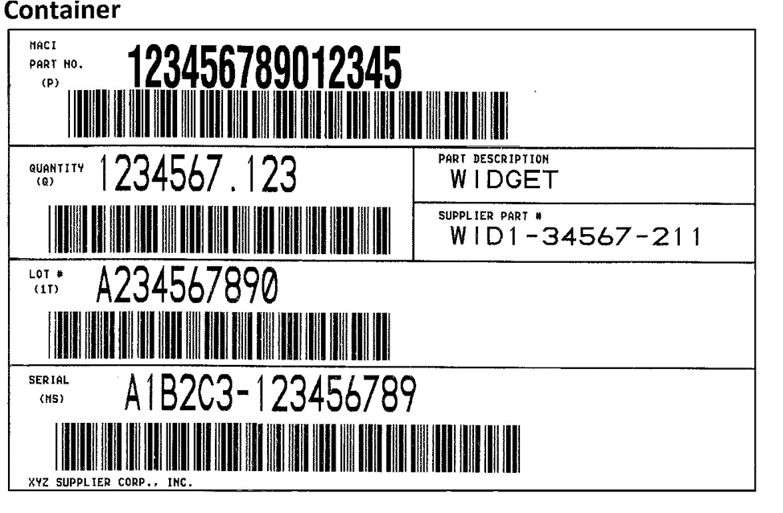
Box MS
Serial #
Box 1T
Lot #
Box Q
Quantity
Box P
Part #

VAN – Value added networks

A “VAN” or Value Added Network is a third party service provider that accepts EDI transactions and holds them in an electronic mailbox for pickup by a trading partner.

If the trading partners (MACI and supplier) have different VANs, the transactions are transferred from one VAN to the other by means of a technique called “Interconnect”.

Trading partners are identified by sender/receiver qualifiers and IDs which are exchanged between MACI and suppliers by e-mail when
the interconnect is setup.
VAN – Value added networks

MACI uses Advantis, owned by Open Text, as its supplier EDI VAN.

It is the responsibility of the supplier to setup the Interconnect between Advantis and the supplier.

Common issues found in MACI Supplier EDI

- When any error on an 856 causes an 824 to be sent to the supplier, the 856 is either not resent at all or too late and receiving must be done manually. This adds a great deal of time and expense to the process.
- Suppliers should receive a 997 in response to a sent 856 within 45 minutes. If they have not, they should contact their VAN or EDI provider to determine if the 856 was received by MACI. If not, they should arrange a resend. Finding out the ASN was not received by MACI days later makes recovery impossible.

Common issues found in MACI Supplier EDI
- The serial numbers and part numbers on the label do not match the serial numbers and part numbers in the ASN. When this happens the shipment must be received manually. Once again, this increases time and expense.

- The master serial number is not unique from the container serial number. This requires receiving to scan each container which is more time consuming than just scanning the master.

- The serial numbers on either the ASN or the label do not follow the rules. 1) The serial number begins with the supplier ID. 2) The remainder of the serial must be exactly 9 digits long. 3) The serial number cannot repeat for three years.

Common issues found in MACI Supplier EDI
- Purchase order release is not open. This seems to confuse many of MACIs suppliers. Instead of correcting the problem the ASN is resent and fails again. If you have trouble with this your MACI representative.
- Lot numbers are missing from the ASN. Currently MACI does not check for missing lot numbers. This will be changing. If you need help contact your primary MACI representative.

Common issues found in MACI Supplier EDI

- Quantities on the ASN do not match the quantities that arrive. This is a very important issue. If the ASN indicates there are 5000 parts on the truck and there are only 500 it is possible to shut down production. The 5000 quantity will be entered into inventory and planners will schedule the plant with the expectation the quantity will be in inventory. When production attempts to use inventory not there, a shut-down is possible. This is a serious issue.

Common issues found in MACI Supplier EDI

- Serial number does not include the supplier ID. This often happens when a supplier is changing software providers. If this is not corrected promptly it can prevent receiving from moving stock to inventory.
- The second portion of the serial number is not exactly 9 digits. This is part of database restrictions at MACI. Once again this often occurs during a software change.

