Contents
MACI AIAG Label Details 1
Individual Container Labels 3
Box P - MACI Part Number 3
Box Q - Container Quantity 4
Box 1T – Lot Number 4
Box MS - Serial Number 5
Box Part Description 6
Box Supplier Part Number 6
Master or Pallet Level Labels 7
Box P - MACI Part Number 8
Box Q – Container Quantity 8
Box 1T – Lot Number 9
Master MM - Serial Number 10
Box Part Description 10
Box Supplier Part Number 10
Appendices 11
Notifications 11
Contacts: 11

MACI AIAG Label Details

1. Labels may be any size media as long as they can accommodate the required information and container.
2. Label must be printed in black on white label or card stock.
3. Label must be adhesive for expendable packaging. Label can be cardstock or adhesive for returnable packaging. If adhesive labels are used with returnable packaging the backing should not be removed.
4. One label is required per smallest unit of packing as delivered to MACI. The Label must be placed on a vertical side as to be visible when containers are stacked.
5. The arrangement of fields is to be determined by the supplier. The single exception to this is the serial field, which must be located in the bottom-left most position on the label.

MACI AIAG Label Data Requirements

Individual Container Labels

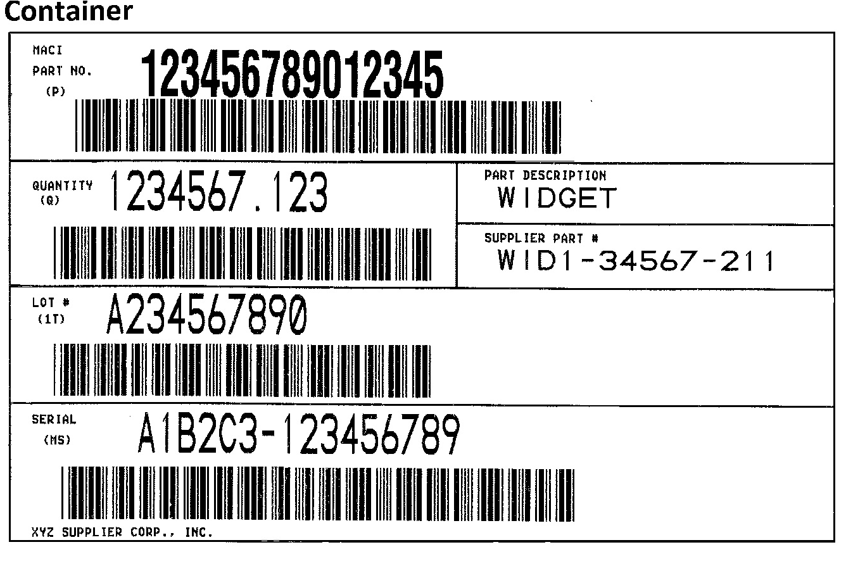

Box P - MACI Part Number
Human Readable Text:
1. This will contain the MACI part number, as provided by MACI, in human readable form.
2. The characters must be no smaller than 3/8” and no larger than 1/2”.
3. The text should be in ALL CAPITALS in a sans serif font.

Bar Code:
1. This will contain the MACI part number, as provided by MACI, in bar code form.
2. The bar code will include a prefix data identifier of ‘P’.
3. The bar code should be in the “Code 39” or “3 of 9 Code” format.
4. The bar code should not be less than 3/8” or more than 1/2” in height.

Box Q - Container Quantity
Human Readable Text:
1. This will contain the quantity of the established unit of measure (EA, LBS, etc.) in the labeled container in human readable form.
2. The characters must be no smaller than 3/8” and no larger than 1/2”.
3. The human readable text can be up to 7, 3 characters in length but should not contain any leading zeros (i.e. 100 not 000100). Non-significant digits may be excluded (i.e. 9,999,999 not 9,999,999.000).
4. The text should be in a sans serif font.

Bar Code:
1. This will contain the quantity of the established unit of measure (EA, LBS, etc.) in the labeled container in bar code form.
2. The bar code will include a prefix data identifier of ‘Q’.
3. The bar code should be in the “Code 39” or “3 of 9 Code” format.
4. The bar code should not be less than 3/8” or more than 1/2” in height.
5. The bar code can be up to 11 characters in length but should not contain leading zeros (i.e. Q100 not Q000100).

Box 1T – Lot Number
Human Readable Text:
1. This will contain the supplier generated lot number for the labeled container in human readable form. The purpose of this lot number is for quality assurance traceability and should be either the manufacturing lot or some other appropriate reference number, known to and tracked by the supplier (i.e.: ship date).
2. The characters must be no smaller than 3/8” and no larger than 1/2”.
3. The human readable text must be between 6 and 10 characters in length.
4. The text should be in a sans serif font.

Bar Code:
1. This will contain the supplier generated lot number for the labeled container in bar code form. The purpose of this lot number is for quality assurance traceability and should be either the manufacturing lot or some other appropriate reference number, known to and tracked by the supplier (i.e.: ship date).
2. The bar code will include a prefix data identifier of ‘1T’.
3. The bar code should be in the “Code 39” or “3 of 9 Code” format.
4. The bar code should not be less than 3/8” or more than 1/2” in height.
5. The bar code should be 10 characters in length. Leading zeros should be used for padding required.

Box MS - Serial Number
The serial number is made up of two pieces of information separated by a hyphen. The first piece of information is the supplier’s vendor code, as assigned by MACI.
The second piece of information is a unique 9 digit incremental number (alpha/numeric) created and provided by the supplier, which may not be repeated in any 36 month time period.

Human Readable Text:
1. This will contain the serial number in human readable form.
2. The characters must be no smaller than 3/8” and no larger than 1/2”.
3. The alpha/numeric portion of the serial number should contain leading zeros (i.e. A1B2C3-000005253). It must be nine (9) characters long.
4. The vendor code portion of the serial number can be up to 6 characters long but should only contain the characters assigned in MACI’s vendor code.
5. The text should be in ALL CAPITALS in a sans serif font.

Bar Code:
1. This will contain the serial number in bar code form.
2. The bar code will include a prefix data identifier of ‘MS’.
3. The bar code may be in either the “Code 39” or “3 of 9 Code” format or the “Code 128-B” format..
4. The bar code should not be less than 3/8” or more than 1/2” in height.
5. The bar code should contain the exact information in the human readable form, with the exception of the hyphen with the addition of the prefix (i.e. MSA1B2C3000005253).

Box Part Description
Human Readable Text:
1. This will contain the supplier part description, as determined by the supplier and MACI, in human readable form.
2. The characters must be no smaller than 1/4” and no larger than 3/8”.
3. The text should be in a sans serif font.

Box Supplier Part Number
Human Readable Text:
1. This will contain the supplier part number as determined by the supplier, in human readable form.
2. The characters must be no smaller than 1/4” and no larger than 3/8”.
3. The text should be in a sans serif font.

Master or Pallet Level Labels

The master or pallet level label contains all of the information of the box or container level label with the exception of additional requirements of the serial number bar code.

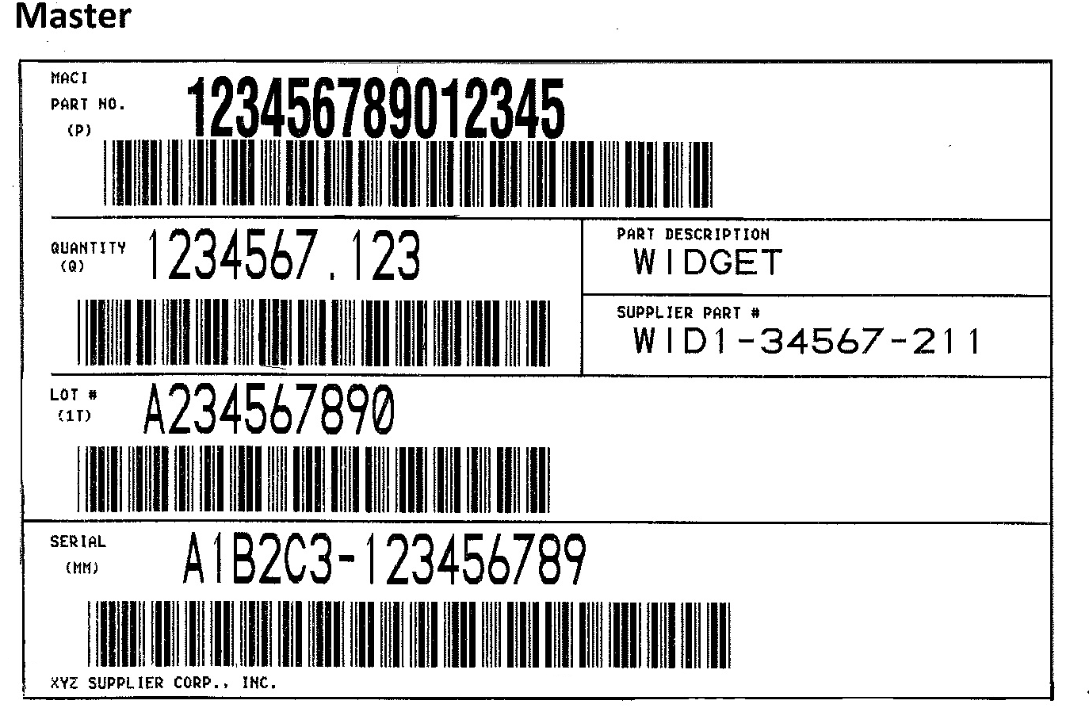

.

Box P - MACI Part Number

Human Readable Text:
1. This will contain the MACI part number, as provided by MACI, in human readable form.
2. The characters must be no smaller than 3/8” and no larger than 1/2”.
3. The text should be in ALL CAPITALS in a sans serif font.

Bar Code:
1. This will contain the MACI part number, as provided by MACI, in bar code form.
2. The bar code will include a prefix data identifier of ‘P’.
3. The bar code should be in the “Code 39” or “3 of 9 Code” format.
4. The bar code should not be less than 3/8” or more than 1/2” in height.

Box Q – Container Quantity
(Total of all containers on this master)

Human Readable Text:
1. This will contain the quantity of the established unit of measure (EA, LBS, etc.) in the labeled container in human readable form.
2. The characters must be no smaller than 3/8” and no larger than 1/2”.
3. The human readable text can be up to 7, 3 characters in length but should not contain any leading zeros (i.e. 100 not 000100). Non-significant digits may be excluded (i.e. 9,999,999 not 9,999,999.000).
4. The text should be in a sans serif font.

Bar Code:
1. This will contain the quantity of the established unit of measure (EA, LBS, etc.) in the labeled container in bar code form.
2. The bar code will include a prefix data identifier of ‘Q’.
3. The bar code should be in the “Code 39” or “3 of 9 Code” format.
4. The bar code should not be less than 3/8” or more than 1/2” in height.
5. The bar code can be up to 11 characters in length but should not contain leading zeros (i.e. Q100 not Q000100).

Box 1T – Lot Number

Human Readable Text:
1. This will contain the supplier generated lot number for the labeled container in human readable form. The purpose of this lot number is for quality assurance traceability and should be either the manufacturing lot or some other appropriate reference number, known to and tracked by the supplier (i.e.: ship date).
2. The characters must be no smaller than 3/8” and no larger than 1/2”.
3. The human readable text must be between 6 and 10 characters in length.
4. The text should be in a sans serif font.

Bar Code:
1. This will contain the supplier generated lot number for the labeled container in bar code form. The purpose of this lot number is for quality assurance traceability and should be either the manufacturing lot or some other appropriate reference number, known to and tracked by the supplier (i.e.: ship date).
2. The bar code will include a prefix data identifier of ‘1T’.
3. The bar code should be in the “Code 39” or “3 of 9 Code” format.
4. The bar code should not be less than 3/8” or more than 1/2” in height.
5. The bar code should be 10 characters in length. Leading zeros should be used for padding required.

Master MM - Serial Number

The serial number is made up of two pieces of information separated by a hyphen. The first piece of information is the supplier’s vendor code, as assigned by MACI.
The second piece of information is a unique 9 digit incremental number (alpha/numeric) created and provided by the supplier, which may not be repeated in any 12 month time period.
Human Readable Text:
1. This will contain the serial number in human readable form.
2. The characters must be no smaller than 3/8” and no larger than 1/2”.
3. The alpha/numeric portion of the serial number should contain leading zeros (i.e. A1B2C3-000005253). It must be nine (9) characters long.
4. The vendor code portion of the serial number can be up to 6 characters long but should only contain the characters assigned in MACI’s vendor code.
5. The text should be in ALL CAPITALS in a sans serif font.

Bar Code:
1. This will contain the serial number in bar code form.
2. The bar code will include a prefix data identifier of ‘MM’.
3. The bar code must be in the “Code 128 - B” format to meet receiving’s requirement that the serial number be scan-able from a distance of a minimum of six feet.
4. The bar code should not be less than 3/8” or more than 1/2” in height and between 4 ½ inches and 5 ½ inches in length.
5. The bar code should contain the exact information in the human readable form, with the exception of the hyphen and the addition of the prefix (i.e. MMA1B2C3000005253).

Box Part Description
Human Readable Text:
1. This will contain the supplier part description, as determined by the supplier and MACI, in human readable form.
2. The characters must be no smaller than 1/4” and no larger than 3/8”.
3. The text should be in a sans serif font.

Box Supplier Part Number
Human Readable Text:
1. This will contain the supplier part number as determined by the supplier, in human readable form.
2. The characters must be no smaller than 1/4” and no larger than 3/8”.
3. The text should be in a sans serif font.

Appendices

Notifications

MACI’s current AIAG Label Specifications are based on the Automotive Industry Action Group’s B-3 Shipping/Parts Identification Label Standard. If MACI finds areas of the label that need to be adjusted to meet the AIAG B-3 Specifications we will notify suppliers of the new MACI Specifications as soon as possible.

Contacts:

Michigan Automotive Compressor, Inc.
2400 N. Dearing Road
P.O. Box 69
Parma, MI 49269
(517) 531-5680 (fax)
(517) 531-5500

Production Control Planning:  Beth Rowe  Manager  (517) 796-3350 | Production Control Planning:  Beth Jewel  Supervisor  (517) 796-3238
Information Systems:  Jeff Kaiser  Specialist  (517) 796-3335 | Information Systems:  Tom Stanton  Senior Advanced Specialist  (517) 796-3368
Information Systems:
Ed McClendon
EDI Senior Specialist
(517) 796-3269

Production Control Logistics:
Ron Snyder
Production Control Logistics Supervisor
(517) 796-3304

Purchasing:  Heidi Curl  Manager  (517) 796-3414 | Purchasing:  Janis Ortiz  Senior Specialist  (517) 796-3415

